Pipeline Tasks

1)Create one Declarative pipeline job https://github.com/betawins/spring3-mvc-maven-xml-hello-world-1.git

Declarative Pipeline:

pipeline {
agent any

tools {
maven 'MAVEN_HOME'
}

environment {
NEXUS_VERSION = "${env.NEXUS_VERSION ?: 'nexus3'}"
NEXUS_PROTOCOL = "${env.NEXUS_PROTOCOL ?: 'http'}"
NEXUS_URL = "${env.NEXUS_URL ?: '107.23.211.86:8081'}"
NEXUS_REPOSITORY = "${env.NEXUS_REPOSITORY ?: 'devops'}"
NEXUS_CREDENTIAL_ID = "${env.NEXUS_CREDENTIAL_ID ?: 'Nexus_server'}"

SONARQUBE_SERVER = "${env.SONARQUBE_SERVER ?: 'MySonarQube'}"

SLACK_CHANNEL = "${env.SLACK_CHANNEL ?: '#new-channel'}"

REPO_URL = "https://github.com/mubeen-hub78/spring3-mvc-maven-xml-hello-world-1.git"
GIT_BRANCH = "master"
}

stages {
stage('Checkout') {
steps {
git branch: "${env.GIT_BRANCH}", url: "${env.REPO_URL}"
}
}

stage('Build') {
steps {
sh 'mvn -Dmaven.test.failure.ignore=true clean install'
}
}

stage('SonarQube Analysis') {
steps {
withSonarQubeEnv("${env.SONARQUBE_SERVER}") {
sh 'mvn sonar:sonar'
}
}
}

stage('Publish to Nexus') {
steps {
script {
def pom = readMavenPom file: 'pom.xml'
def artifacts = findFiles(glob: "target/*.${pom.packaging}")

if (artifacts.size() == 0) {
error "No artifact found for packaging type: ${pom.packaging}"
}

def artifactPath = artifacts[0].path

withCredentials([usernamePassword(credentialsId: "${env.NEXUS_CREDENTIAL_ID}", usernameVariable: 'NEXUS_USER', passwordVariable: 'NEXUS_PASS')]) {
nexusArtifactUploader(
nexusVersion: "${env.NEXUS_VERSION}",
protocol: "${env.NEXUS_PROTOCOL}",
nexusUrl: "${env.NEXUS_URL}",
groupId: pom.groupId,
version: "${env.BUILD_NUMBER}-SNAPSHOT",
repository: "${env.NEXUS_REPOSITORY}",
credentialsId: "${env.NEXUS_CREDENTIAL_ID}",
artifacts: [
[artifactId: pom.artifactId, classifier: '', file: artifactPath, type: pom.packaging],
[artifactId: pom.artifactId, classifier: '', file: 'pom.xml', type: 'pom']
]
)
}
}
}
}
}

post {
success {
slackSend(channel: "${env.SLACK_CHANNEL}", color: 'good', message: "✅ SUCCESS: Job '${env.JOB_NAME} [${env.BUILD_NUMBER}]' (<${env.BUILD_URL}|Open>)")
}
failure {
slackSend(channel: "${env.SLACK_CHANNEL}", color: 'danger', message: "❌ FAILURE: Job '${env.JOB_NAME} [${env.BUILD_NUMBER}]' (<${env.BUILD_URL}|Open>)")
}
unstable {
slackSend(channel: "${env.SLACK_CHANNEL}", color: 'warning', message: "⚠️ UNSTABLE: Job '${env.JOB_NAME} [${env.BUILD_NUMBER}]'")
}
}
}

Explanation of Pipeline Blocks
- pipeline { ... }
Defines the entire Jenkins declarative pipeline.
- agent any
Runs the pipeline on any available Jenkins agent.
- tools { maven 'MAVEN_HOME' }
Declares the Maven tool installation named MAVEN_HOME from Jenkins global tools to be used.
- environment { ... }
Sets environment variables used throughout the pipeline, such as Nexus, SonarQube, Slack configuration, and Git repository info.
- stages { ... }
Defines sequential build stages to perform in the pipeline.
  - stage('Checkout')
Checks out the source code from the specified Git branch and repository.
  - stage('Build')
Runs a Maven build with tests ignored to compile and package the project.
  - stage('SonarQube Analysis')
Performs static code analysis by running the SonarQube scanner configured in Jenkins.
  - stage('Publish to Nexus')
Reads Maven POM, finds build artifacts, and uploads them to Nexus repository using credentials. The version uploaded is dynamically set to include the Jenkins build number with the -SNAPSHOT suffix.
- post { ... }
Defines actions triggered after pipeline execution based on build results:
  - success - Sends a green Slack notification indicating successful build.
  - failure - Sends a red Slack notification indicating build failure.
  - unstable - Sends a warning Slack notification for unstable builds (e.g., tests failed but build passed).

Create a jenkins job and configure as Pipeline script from SCM.
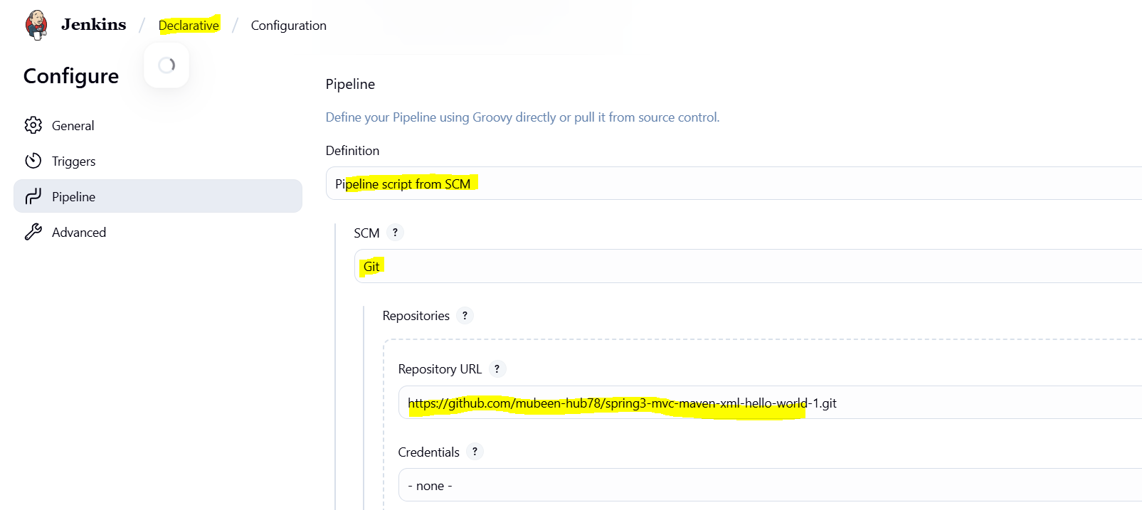

Add git repo url, master and Script path as Jenkinsfile.

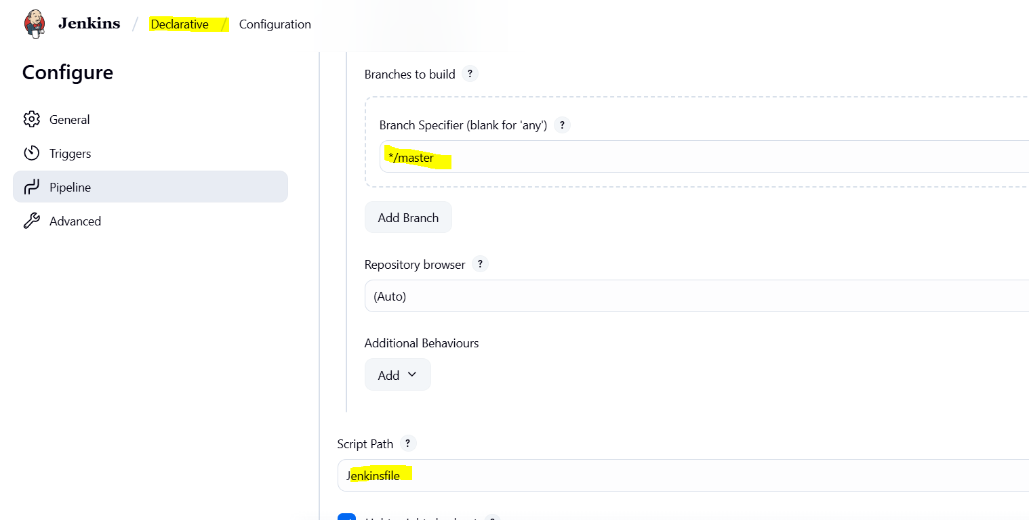
After configuring click on Build Now.
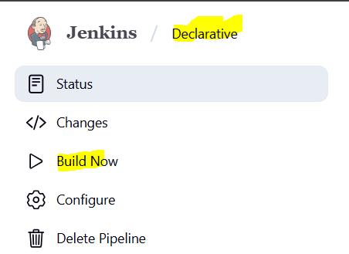
Console Output after the job and Stage view.

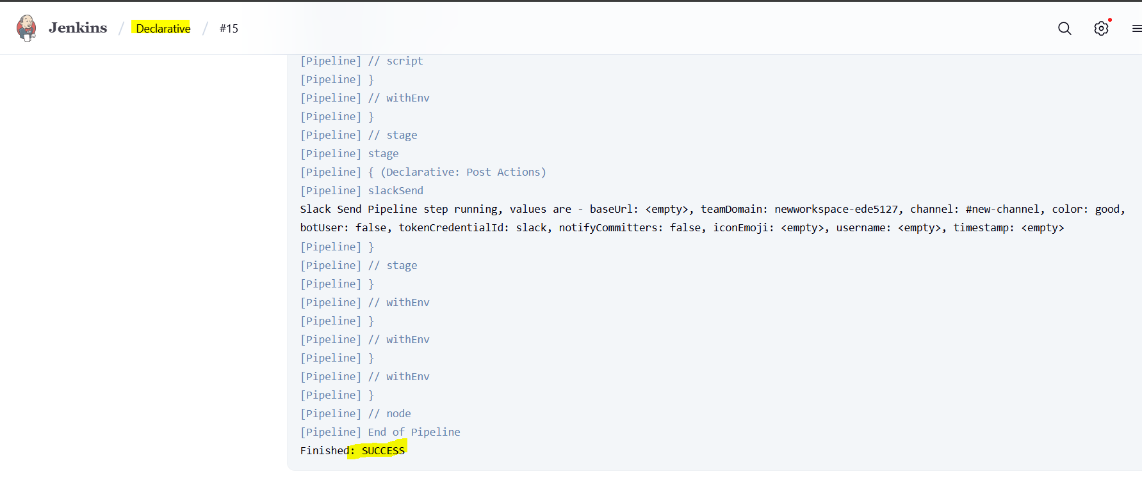
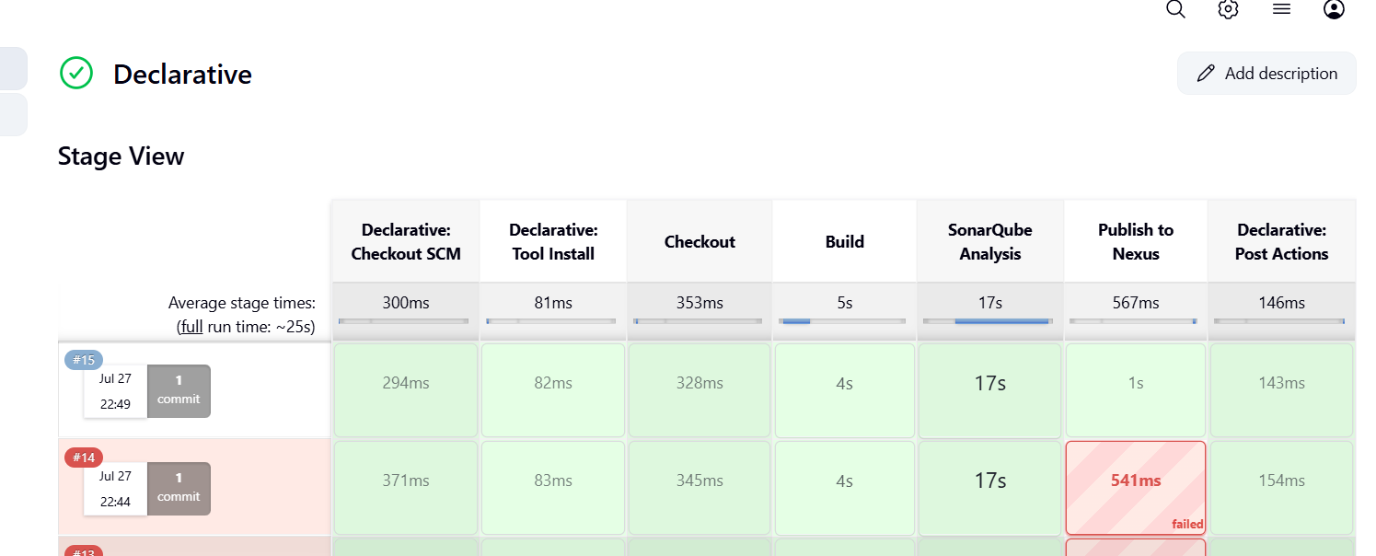

SonarQube Output, Code quality check and analysis.

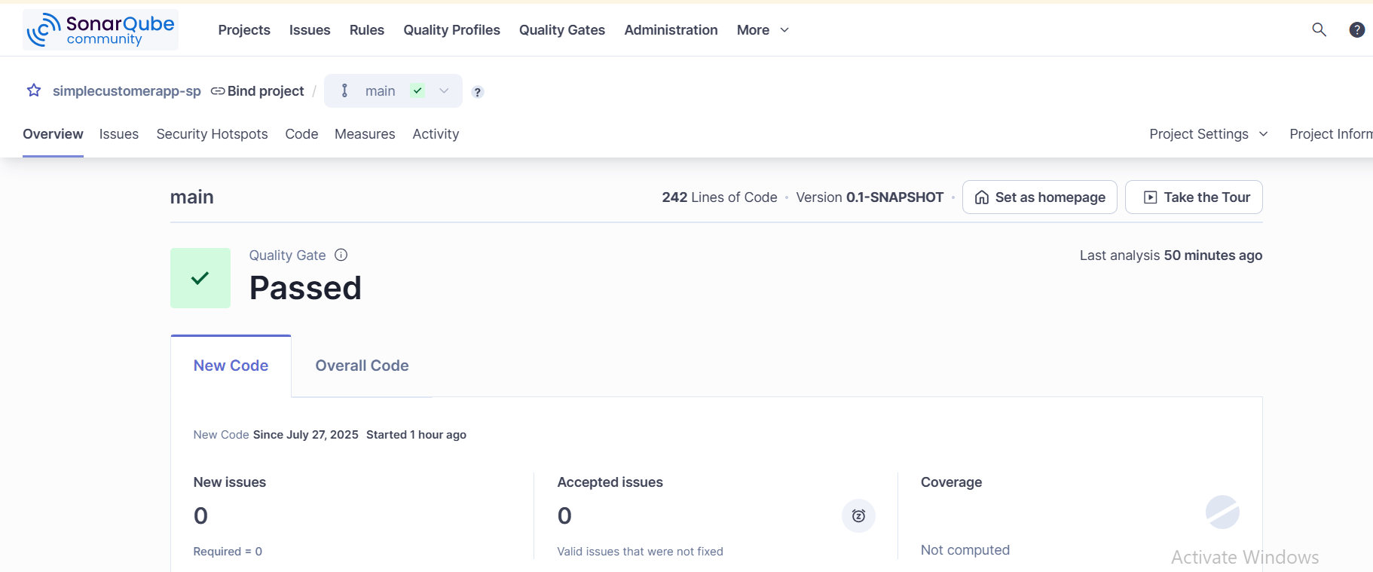

Artifact stored in Nexus artifactory.

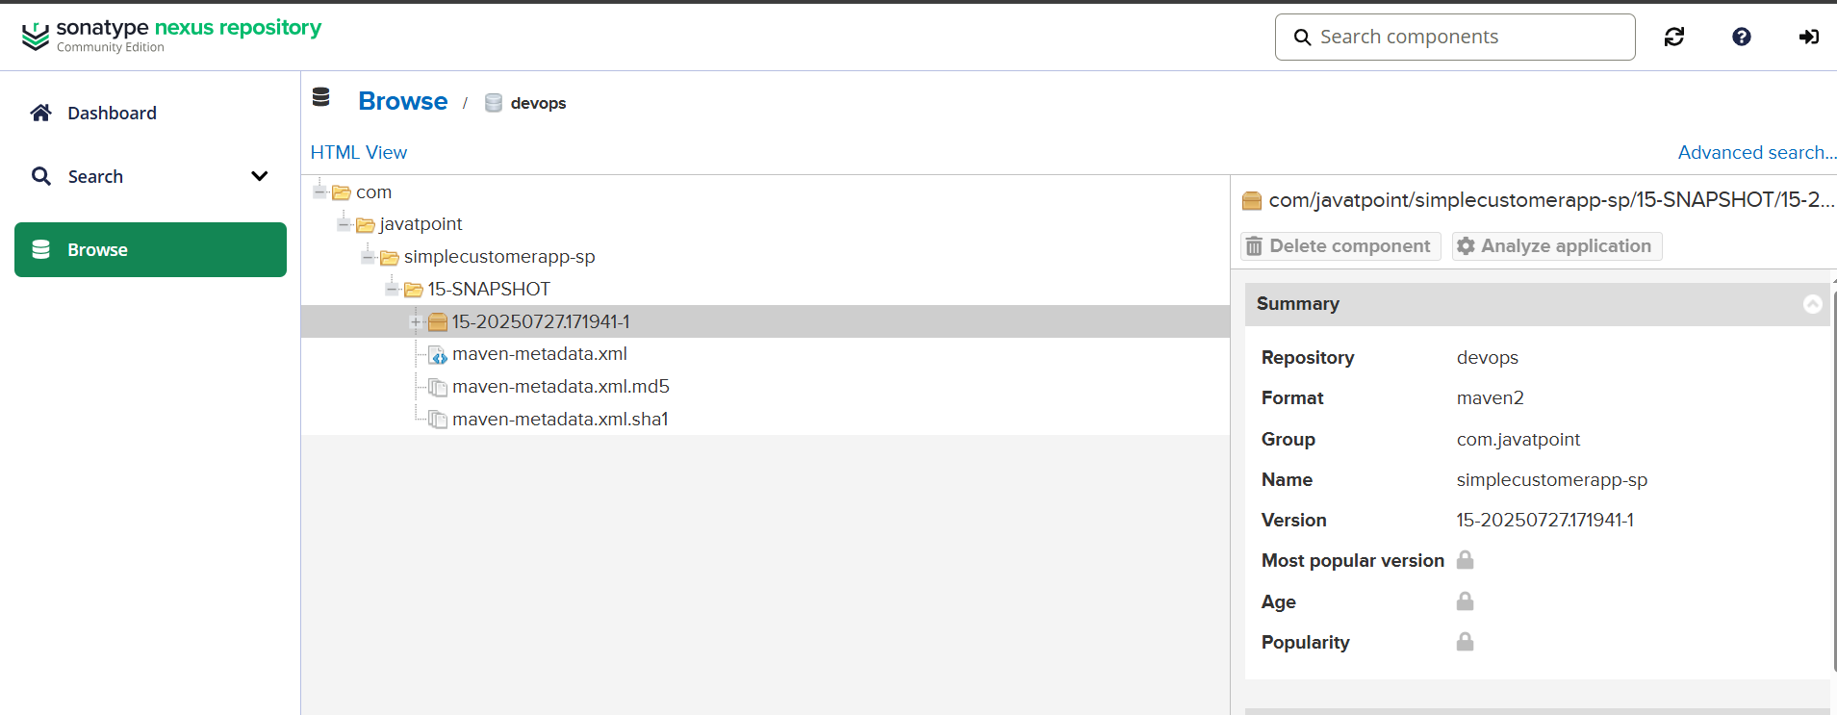
Post Build action, Slack notification as Success.

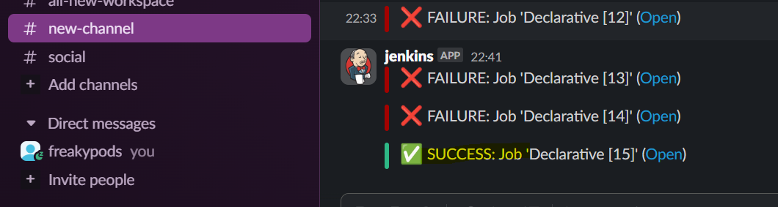

2) Create one scripted pipeline job https://github.com/betawins/spring3-mvc-maven-xml-hello-world-1.git

node {
// -------- Config (same repo & conf, just “-scripted” identities) --------
def REPO_URL = 'https://github.com/mubeen-hub78/spring3-mvc-maven-xml-hello-world-1.git'
def GIT_BRANCH = 'master'

def SONARQUBE_SERVER = (env.SONARQUBE_SERVER ?: 'MySonarQube')
def SONAR_PROJECT_KEY = 'simplecustomerapp-sp-scripted'
def SONAR_PROJECT_NAME = 'simplecustomerapp-sp-scripted'

def NEXUS_VERSION = (env.NEXUS_VERSION ?: 'nexus3')
def NEXUS_PROTOCOL = (env.NEXUS_PROTOCOL ?: 'http')
def NEXUS_URL = (env.NEXUS_URL ?: '107.23.211.86:8081')
def NEXUS_REPOSITORY = (env.NEXUS_REPOSITORY ?: 'devops')
def NEXUS_CREDENTIAL_ID = (env.NEXUS_CREDENTIAL_ID ?: 'Nexus_server')

def SLACK_CHANNEL = (env.SLACK_CHANNEL ?: '#new-channel')

try {
stage('Checkout') {
checkout([$class: 'GitSCM',
branches: [[name: "*/${GIT_BRANCH}"]],
userRemoteConfigs: [[url: REPO_URL]]
])
}

stage('Build & Sonar (parallel)') {
parallel(
Build: {
sh 'mvn -Dmaven.test.failure.ignore=true clean install'
},
SonarQube_Analysis: {
withSonarQubeEnv(SONARQUBE_SERVER) {
sh """
mvn sonar:sonar \
-Dsonar.projectKey=${SONAR_PROJECT_KEY} \
-Dsonar.projectName=${SONAR_PROJECT_NAME}
"""
}
}
)
}

stage('Publish to Nexus') {
def pom = readMavenPom file: 'pom.xml'
def artifacts = findFiles(glob: "target/*.${pom.packaging}")
if (!artifacts || artifacts.size() == 0) {
error "No artifact found for packaging type: ${pom.packaging}"
}
def artifactPath = artifacts[0].path
def versionString = "${env.BUILD_NUMBER}-SNAPSHOT"

withCredentials([usernamePassword(credentialsId: NEXUS_CREDENTIAL_ID,
usernameVariable: 'NEXUS_USER',
passwordVariable: 'NEXUS_PASS')]) {
nexusArtifactUploader(
nexusVersion: NEXUS_VERSION,
protocol: NEXUS_PROTOCOL,
nexusUrl: NEXUS_URL,
groupId: pom.groupId,
version: versionString,
repository: NEXUS_REPOSITORY,
credentialsId: NEXUS_CREDENTIAL_ID,
artifacts: [
[artifactId: pom.artifactId, classifier: '', file: artifactPath, type: pom.packaging],
[artifactId: pom.artifactId, classifier: '', file: 'pom.xml', type: 'pom']
]
)
}
}

currentBuild.result = 'SUCCESS'
} catch (err) {
currentBuild.result = 'FAILURE'
throw err
} finally {
// Simple Slack notify
def color = (currentBuild.result == 'SUCCESS') ? 'good' : 'danger'
slackSend(channel: SLACK_CHANNEL, color: color,
message: "${currentBuild.result}: Job '${env.JOB_NAME} [${env.BUILD_NUMBER}]' (<${env.BUILD_URL}|Open>)")
}
}

Explanation of Pipeline Blocks
node { ... }
Defines the entire Jenkins Scripted Pipeline that contains all stages, environment variables, and build steps. All commands inside this block execute on the allocated Jenkins agent.
env.VARIABLES
Environment variables are defined inside the node block for reuse across all stages:
- Nexus server details (URL, repository, credentials).
- SonarQube server name (used for code analysis).
- Slack channel for notifications.
- Git repository and branch info.
stage('...') { ... }
Each stage represents a step in the build lifecycle. Jenkins executes these stages sequentially.

Stage Explanations
stage('Checkout')
- Pulls the code from the Git repository (https://github.com/mubeen-hub78/spring3-mvc-maven-xml-hello-world-1.git) using the specified branch (master).
stage('Build')
- Executes Maven command mvn -Dmaven.test.failure.ignore=true clean install to:
  - Clean any previous build artifacts.
  - Compile the Java source code.
  - Run unit tests (ignoring failures).
  - Package the application into a .war or .jar.
stage('SonarQube Analysis')
- Runs static code analysis with mvn sonar:sonar.
- Uses the configured SonarQube server (MySonarQube-scripted) to publish code quality metrics such as bugs, code smells, and coverage.
stage('Publish to Nexus')
- Reads pom.xml using readMavenPom to fetch Maven coordinates (groupId, artifactId, version, packaging).
- Finds the generated artifact inside target/.
- Uses nexusArtifactUploader to upload:
  - The built artifact (.war or .jar).
  - The project’s POM file.
- Uses Nexus credentials (Nexus_server) to authenticate.

Notifications
- On Success: Sends a green Slack notification to #new-channel.
- On Failure: Sends a red Slack notification indicating which build failed.
- On Unstable: Sends a yellow warning Slack notification (e.g., test failures).

Create and configure the job.

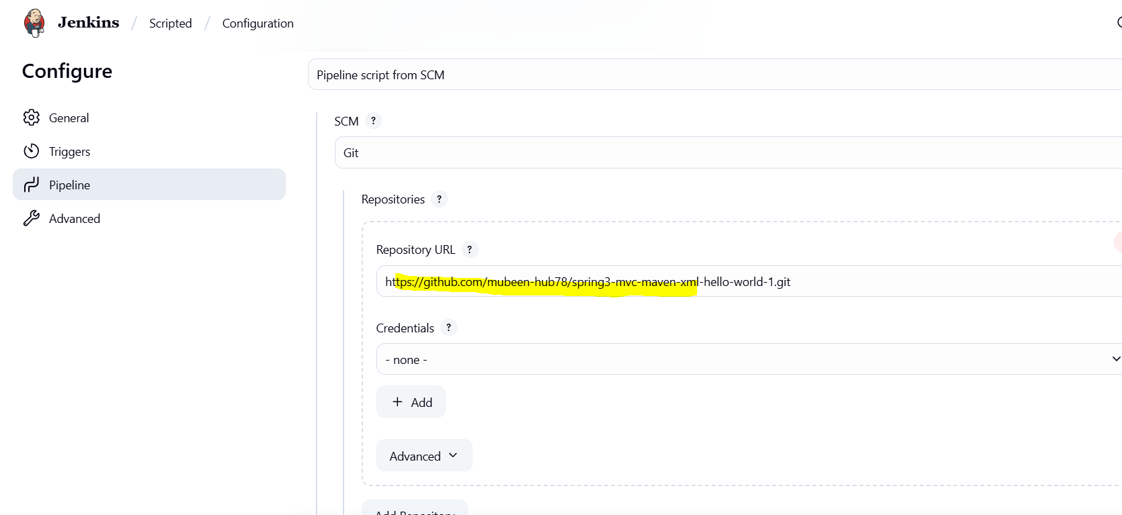
Click on Build now.

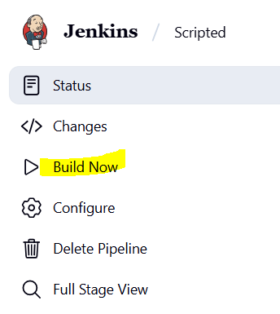

Console output and stage view.

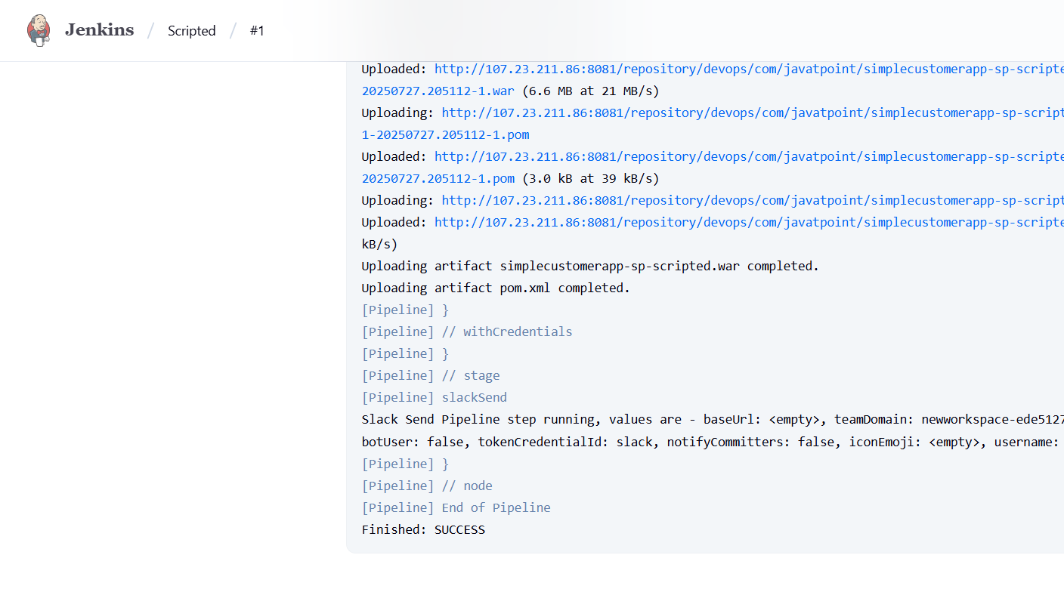

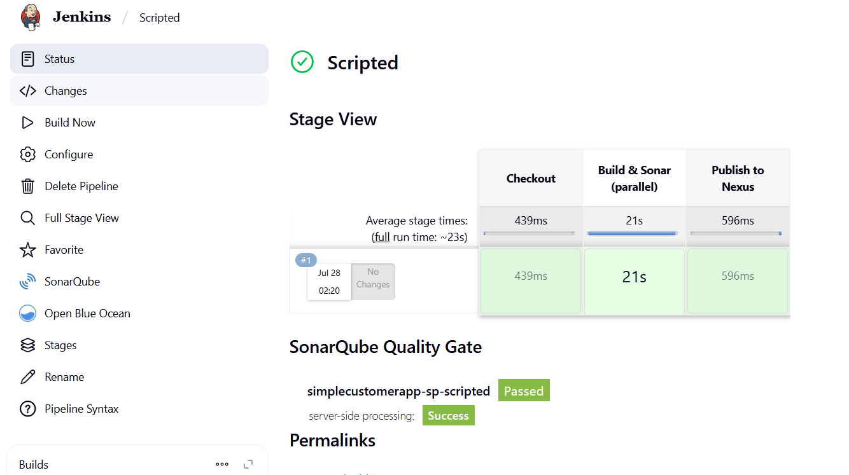

SonarQube quality analysis of code.

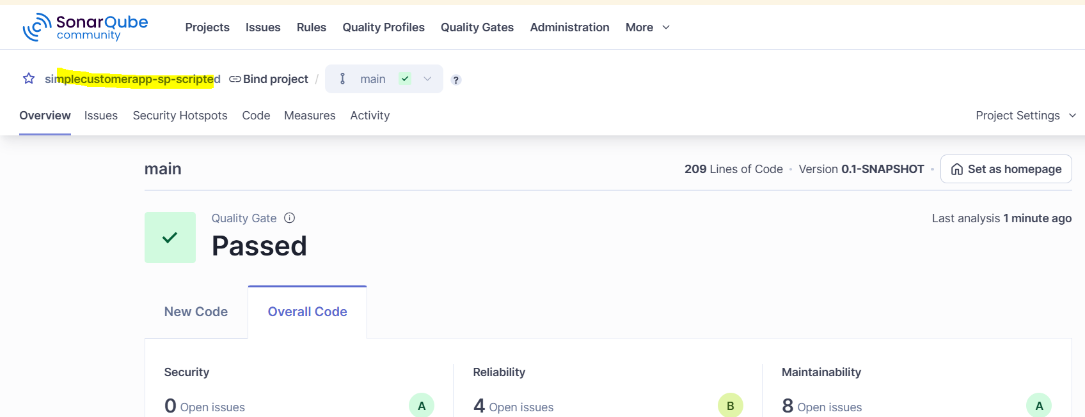

Artifact stored in Nexus.

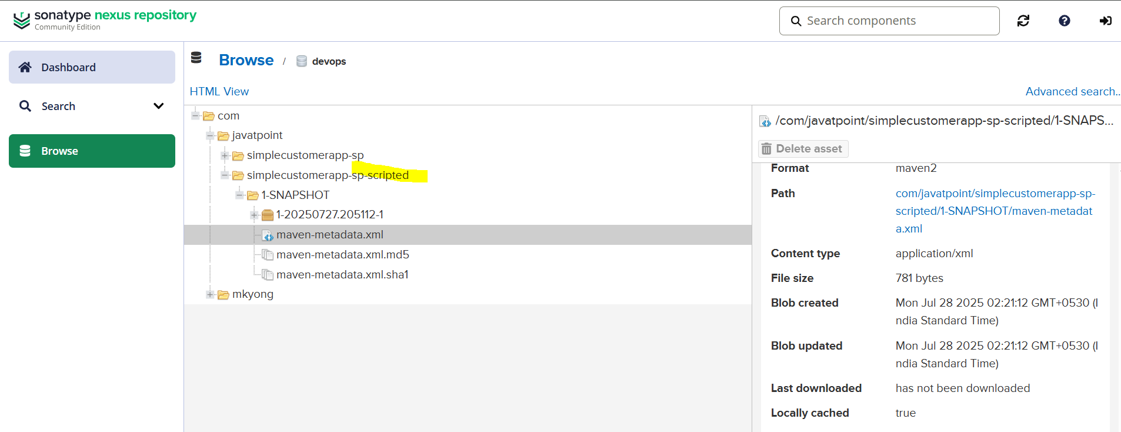

Post Build action as Success.

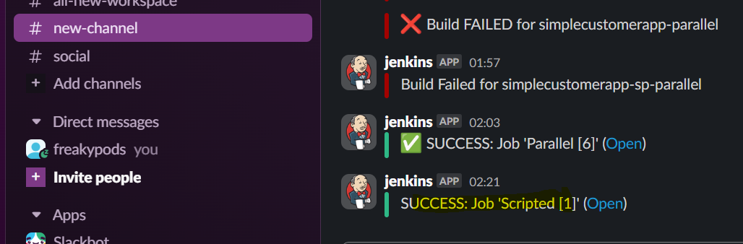

3) Create one parametirized job https://github.com/betawins/spring3-mvc-maven-xml-hello-world-1.git

Parameterized pipelines are a superset of declarative pipelines, designed to enhance reusability and flexibility by accepting runtime inputs. While declarative pipelines focus on easy readability and strict structure, adding parameters makes the pipeline adaptable to diverse deployment needs without code changes

pipeline {
agent any

parameters {
string(name: 'GIT_BRANCH', defaultValue: 'master', description: 'Git branch to build')
string(name: 'SLACK_CHANNEL', defaultValue: '#new-channel', description: 'Slack channel for notifications')
string(name: 'SONARQUBE_PROJECT_KEY', defaultValue: 'com.javatpoint:simplecustomerapp-sp', description: 'SonarQube project key')
string(name: 'SONARQUBE_PROJECT_NAME', defaultValue: 'simplecustomerapp-parameterized', description: 'SonarQube project name')
}

tools {
maven 'MAVEN_HOME'
}

environment {
SONARQUBE_SERVER = 'MySonarQube'
NEXUS_REPO_URL = 'http://107.23.211.86:8081/repository/devops/'
}

stages {
stage('Checkout') {
steps {
git branch: "${params.GIT_BRANCH}", url: 'https://github.com/mubeen-hub78/spring3-mvc-maven-xml-hello-world-1.git'
}
}

stage('Build') {
steps {
sh 'mvn clean install -Dmaven.test.failure.ignore=true'
}
}

stage('SonarQube Analysis') {
steps {
withCredentials([string(credentialsId: 'sonarqube-token', variable: 'SONARQUBE_TOKEN')]) {
withSonarQubeEnv("${env.SONARQUBE_SERVER}") {
sh """
mvn sonar:sonar \
-Dsonar.projectKey=${params.SONARQUBE_PROJECT_KEY} \
-Dsonar.projectName=${params.SONARQUBE_PROJECT_NAME} \
-Dsonar.login=$SONARQUBE_TOKEN
"""
}
}
}
}

stage('Deploy to Nexus') {
steps {
withCredentials([usernamePassword(credentialsId: 'Nexus_server', usernameVariable: 'NEXUS_USER', passwordVariable: 'NEXUS_PASS')]) {
sh '''
cat > settings.xml <<EOF
<settings>
<servers>
<server>
<id>nexus</id>
<username>${NEXUS_USER}</username>
<password>${NEXUS_PASS}</password>
</server>
</servers>
</settings>
EOF
mvn clean deploy -DskipTests --settings settings.xml
'''
}
}
}
}

post {
success {
withCredentials([string(credentialsId: 'slack', variable: 'SLACK_TOKEN')]) {
slackSend(
channel: "${params.SLACK_CHANNEL}",
color: 'good',
token: SLACK_TOKEN,
message: "✅ SUCCESS: Job '${env.JOB_NAME} [${env.BUILD_NUMBER}]' (<${env.BUILD_URL}|Open>)"
)
}
}
failure {
withCredentials([string(credentialsId: 'slack', variable: 'SLACK_TOKEN')]) {
slackSend(
channel: "${params.SLACK_CHANNEL}",
color: 'danger',
token: SLACK_TOKEN,
message: "❌ FAILURE: Job '${env.JOB_NAME} [${env.BUILD_NUMBER}]' (<${env.BUILD_URL}|Open>)"
)
}
}
}
}

Explanation of Pipeline Blocks
- pipeline { ... }
Defines the entire Jenkins Declarative Pipeline, which contains all the stages, tools, environment variables, and post-build actions.
- agent any
Instructs Jenkins to run the pipeline on any available agent (node).
- tools { maven 'MAVEN_HOME' }
Declares that the pipeline will use the Maven installation named MAVEN_HOME, which must be configured under Jenkins Global Tool Configuration.
- environment { ... }
Sets global environment variables for the pipeline, including:
  - Nexus repository URL
  - SonarQube server configuration
  - Slack credentials and channel info
  - Other parameters like Git branch or project keys
- stages { ... }
Contains a sequence of steps to be executed in different phases of the build process.

Stage Explanations
- stage('Checkout')
Clones the source code from the configured Git repository and branch using the git step.
- stage('Build')
Runs a Maven build (mvn clean install) to compile the code, run tests (ignored if failing), and package the artifact (WAR/JAR).
- stage('SonarQube Analysis')
Performs static code analysis using the SonarQube scanner.
  - Uses the configured SonarQube server in Jenkins.
  - Publishes code quality metrics like bugs, vulnerabilities, and code coverage.
- stage('Publish to Nexus')
Uploads the Maven-generated artifact (e.g., WAR) to Nexus Repository Manager.
  - Uses credentials (Nexus_server) stored in Jenkins.
  - Automatically pushes SNAPSHOT or RELEASE artifacts based on the POM configuration.

post { ... }
Contains post-build actions executed after all stages are complete:
- success
Sends a green Slack notification indicating that the build and deployment succeeded.
- failure
Sends a red Slack notification if any stage fails.
- unstable (optional)
Can be added to send a warning Slack notification if the build is unstable (e.g., test failures).

Create and configure the job.

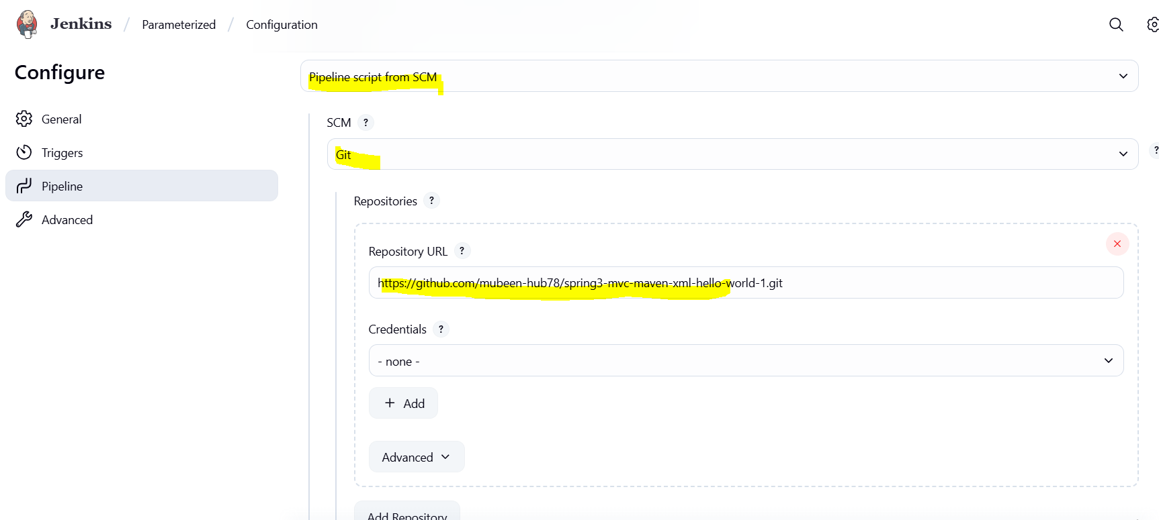

Click on Build with Parameters to run the job, then adjust parameters and click on Build.

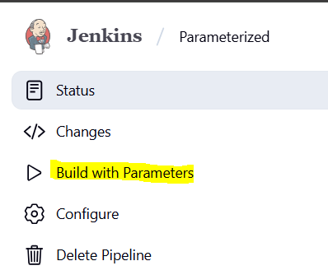
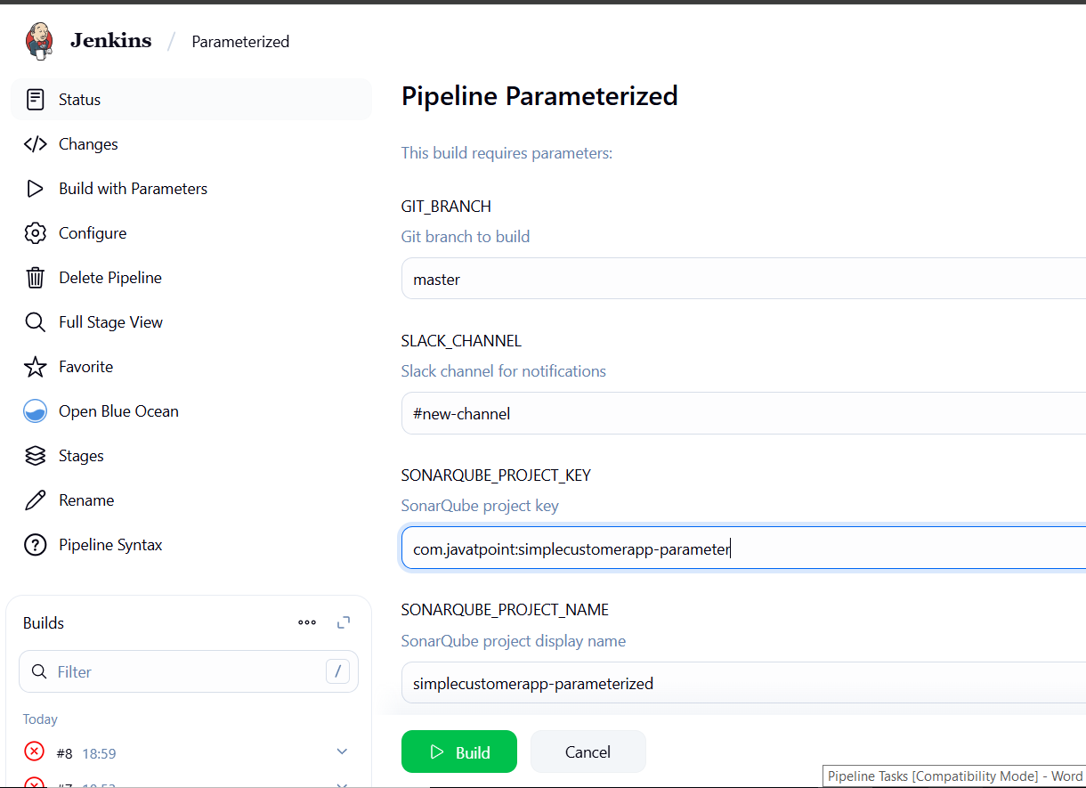

Console output and stage view.

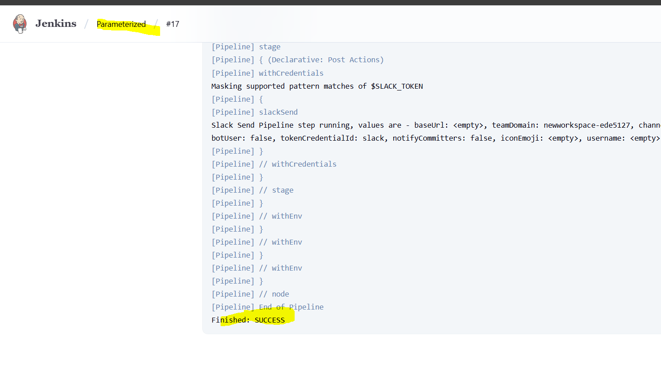
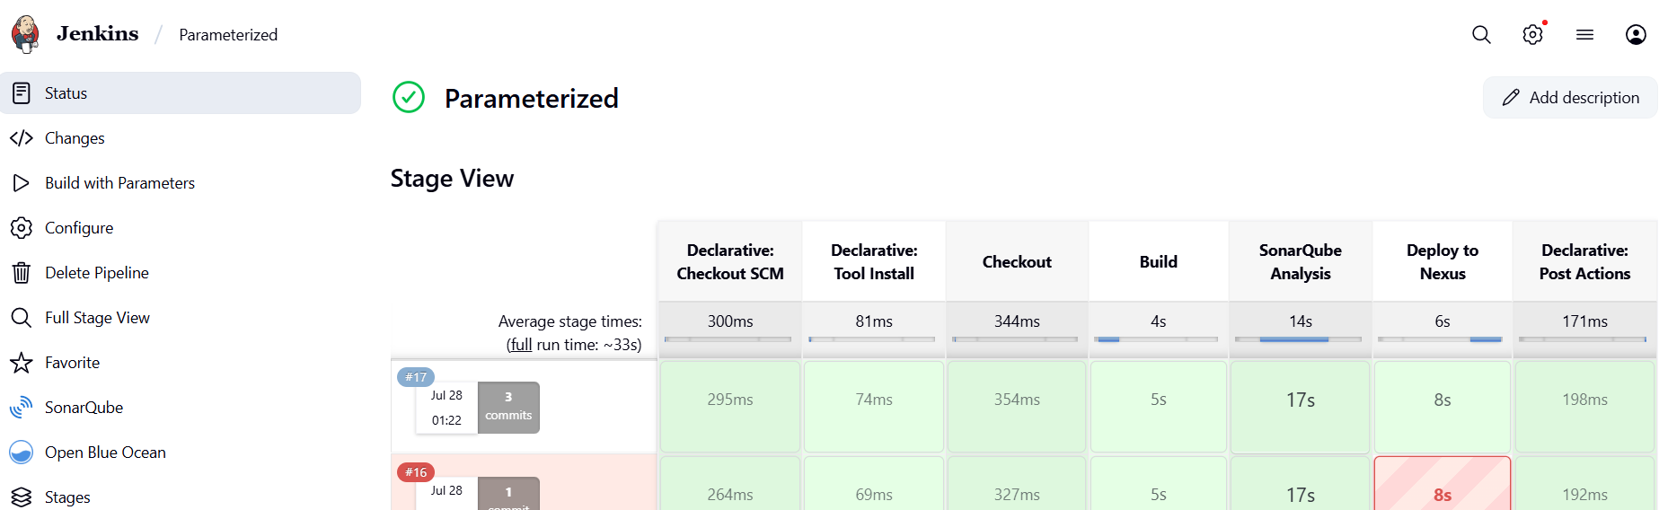

SonarQube output of Quality check.

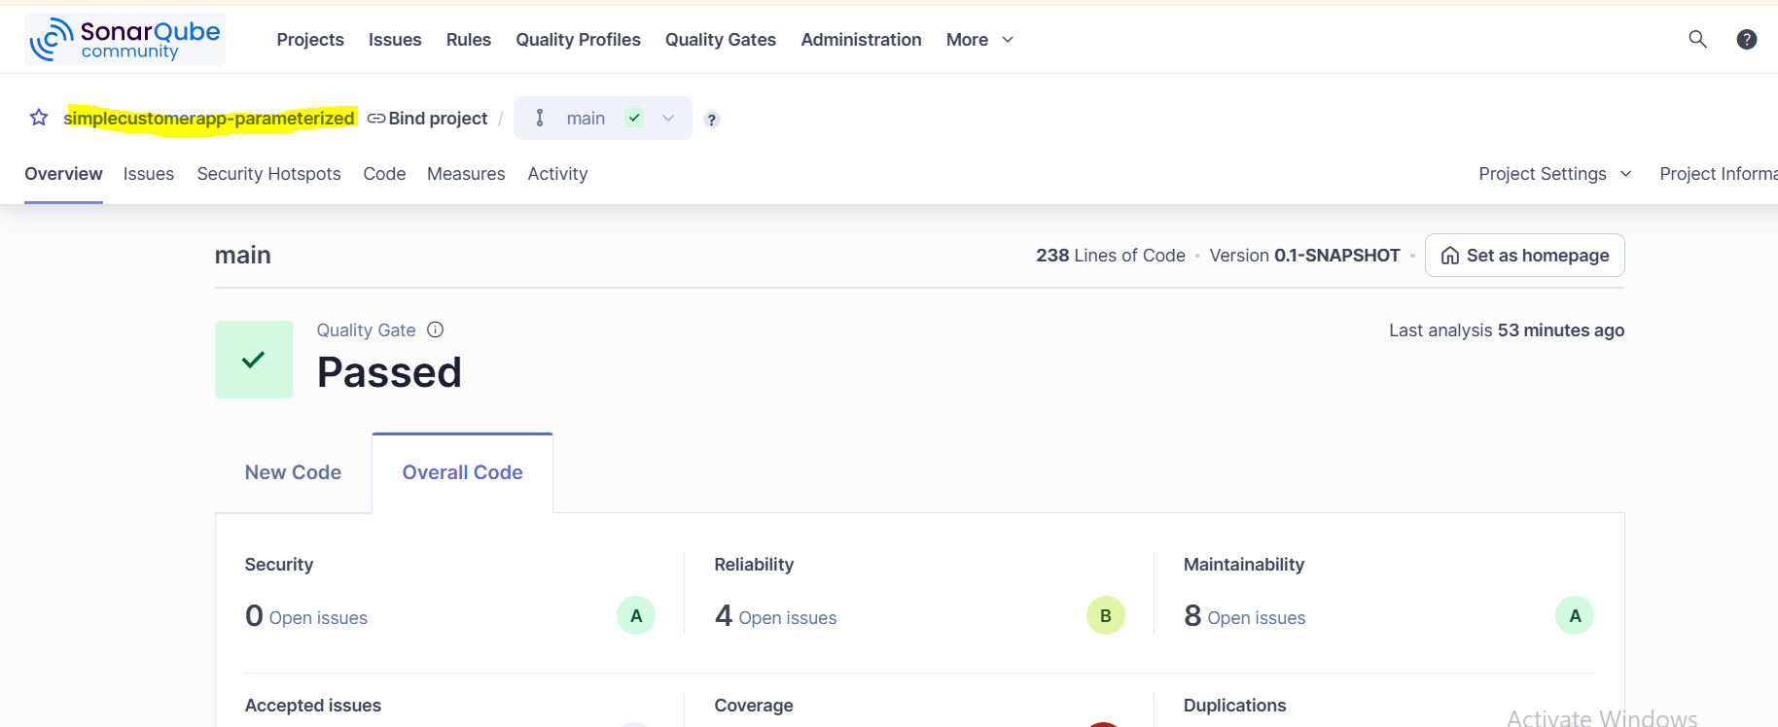

Artifact stored in nexus.

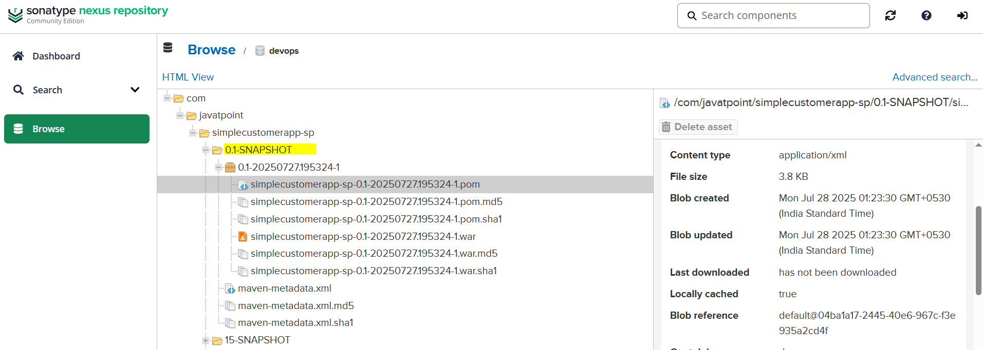
Post build action as Success.

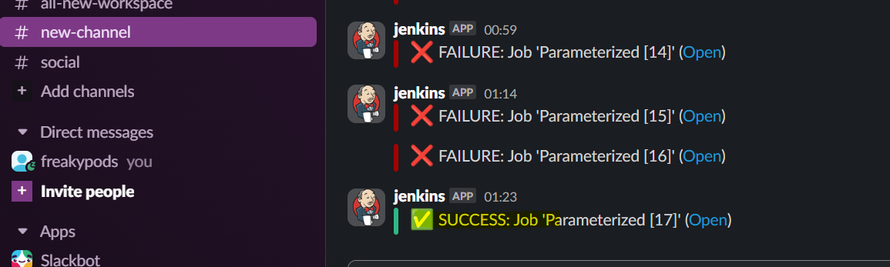
4) Write sample skelton for declarative and scripted pipelines.

Declarative Pipeline Skeleton

pipeline {
agent any

tools {
maven 'MAVEN_HOME'
}

environment {
SONARQUBE = 'MySonar'
DOCKER_CREDS = credentials('docker-hub')
SLACK_CHANNEL = '#devops-alerts'
}

stages {
stage('Checkout') {
steps {
git 'https://github.com/betawins/spring3-mvc-maven-xml-hello-world-1.git'
}
}

stage('Maven Build') {
steps {
sh 'mvn clean install'
}
}

stage('SonarQube Analysis') {
steps {
withSonarQubeEnv("${SONARQUBE}") {
sh 'mvn sonar:sonar'
}
}
}

stage('Docker Build & Push') {
steps {
script {
docker.build('myimage').push('latest')
}
}
}

stage('Kubernetes Deploy') {
steps {
sh 'kubectl apply -f k8s/deployment.yaml'
}
}
}

post {
success {
slackSend(channel: "${SLACK_CHANNEL}", message: "✅ Build Success: ${env.JOB_NAME}")
}
failure {
slackSend(channel: "${SLACK_CHANNEL}", message: "❌ Build Failed: ${env.JOB_NAME}")
}
}
}

Scripted Pipeline Skeleton

node {
def SONARQUBE = 'MySonar'
def SLACK_CHANNEL = '#devops-alerts'

stage('Checkout') {
git 'https://github.com/betawins/spring3-mvc-maven-xml-hello-world-1.git'
}

stage('Maven Build') {
tool name: 'MAVEN_HOME', type: 'maven'
sh 'mvn clean install'
}

stage('SonarQube Analysis') {
withSonarQubeEnv("${SONARQUBE}") {
sh 'mvn sonar:sonar'
}
}

stage('Docker Build & Push') {
withCredentials([usernamePassword(credentialsId: 'docker-hub', usernameVariable: 'DOCKER_USER', passwordVariable: 'DOCKER_PASS')]) {
sh 'docker build -t myimage .'
sh 'echo $DOCKER_PASS | docker login -u $DOCKER_USER --password-stdin'
sh 'docker push myimage:latest'
}
}

stage('Kubernetes Deploy') {
sh 'kubectl apply -f k8s/deployment.yaml'
}

// Post build Slack notification
currentBuild.result = currentBuild.result ?: 'SUCCESS'
if (currentBuild.result == 'SUCCESS') {
slackSend(channel: SLACK_CHANNEL, message: "✅ Build Success: ${env.JOB_NAME}")
} else {
slackSend(channel: SLACK_CHANNEL, message: "❌ Build Failed: ${env.JOB_NAME}")
}
}

5) Create one declarative job https://github.com/betawins/sabear_simplecutomerapp/tree/feature-1.1

pipeline {
agent any

tools {
maven 'MAVEN_HOME'
}

environment {
SONARQUBE = 'MySonar'
NEXUS_URL = 'http://34.204.71.153:8081/repository/devops/'
SLACK_CHANNEL = '#new-channel'
}

stages {
stage('Checkout') {
steps {
git branch: 'master', url: 'https://github.com/mubeen-hub78/mub_simplecutomerapp.git'
}
}

stage('SonarQube Analysis') {
steps {
withSonarQubeEnv("${SONARQUBE}") {
sh 'mvn clean verify sonar:sonar'
}
}
}

stage('Build WAR') {
steps {
sh 'mvn package -DskipTests'
}
}

stage('Upload to Nexus') {
steps {
script {
def warFile = sh(script: "ls target/*.war", returnStdout: true).trim()
withCredentials([usernamePassword(credentialsId: 'Nexus_server', usernameVariable: 'NEXUS_USR', passwordVariable: 'NEXUS_PSW')]) {
sh "mvn deploy:deploy-file -DgroupId=com.javatpoint -DartifactId=SimpleCustomerApp -Dversion=1.0.0-SNAPSHOT -Dpackaging=war -Dfile=${warFile} -DrepositoryId=nexus -Durl=${NEXUS_URL} -DgeneratePom=true -Dusername=${NEXUS_USR} -Dpassword=${NEXUS_PSW}"
}
}
}
}
}

post {
always {
script {
def buildStatus = currentBuild.currentResult ?: 'SUCCESS'
def message = "${buildStatus}: Job ${env.JOB_NAME} #${env.BUILD_NUMBER} (<${env.BUILD_URL}|Details>)"
slackSend(channel: env.SLACK_CHANNEL, tokenCredentialId: 'slack', message: message)
}
}
}
}

Create and configure the job.

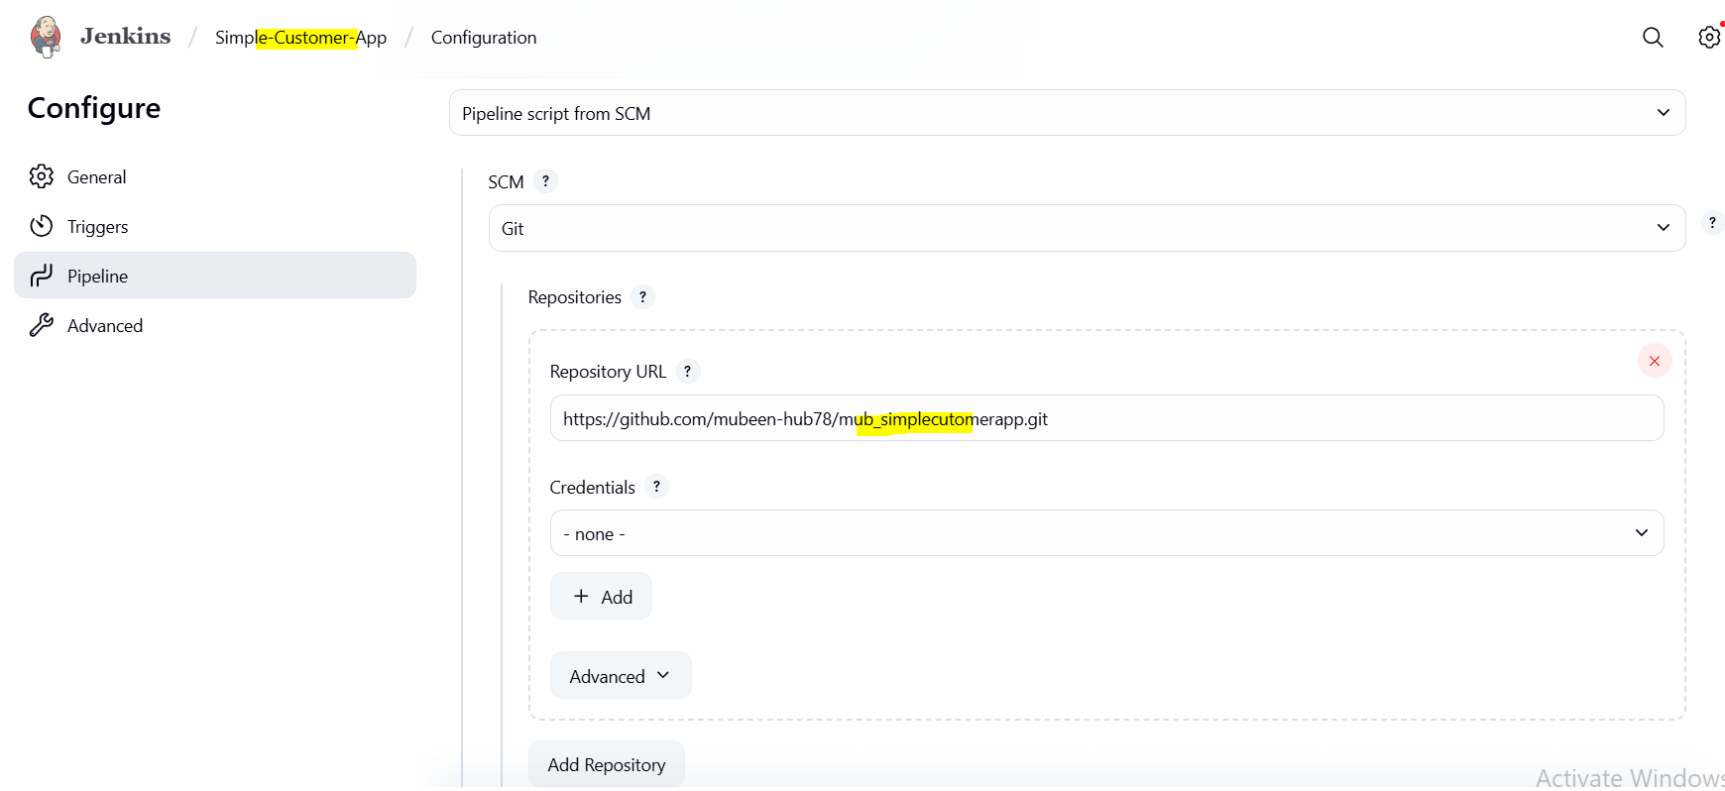

Click on Build Now.

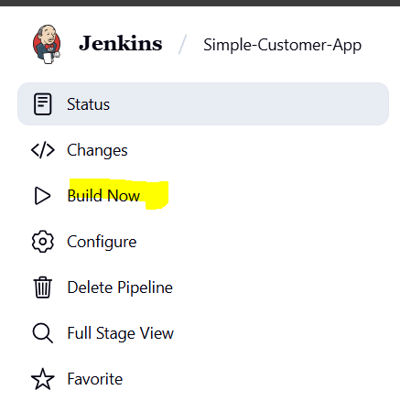

Console output and stage view.

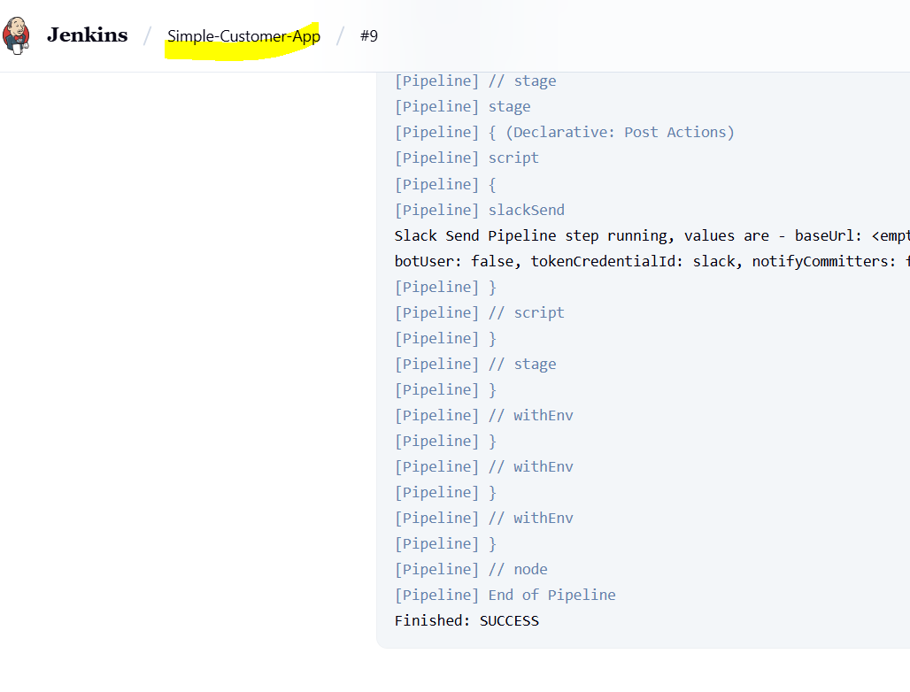

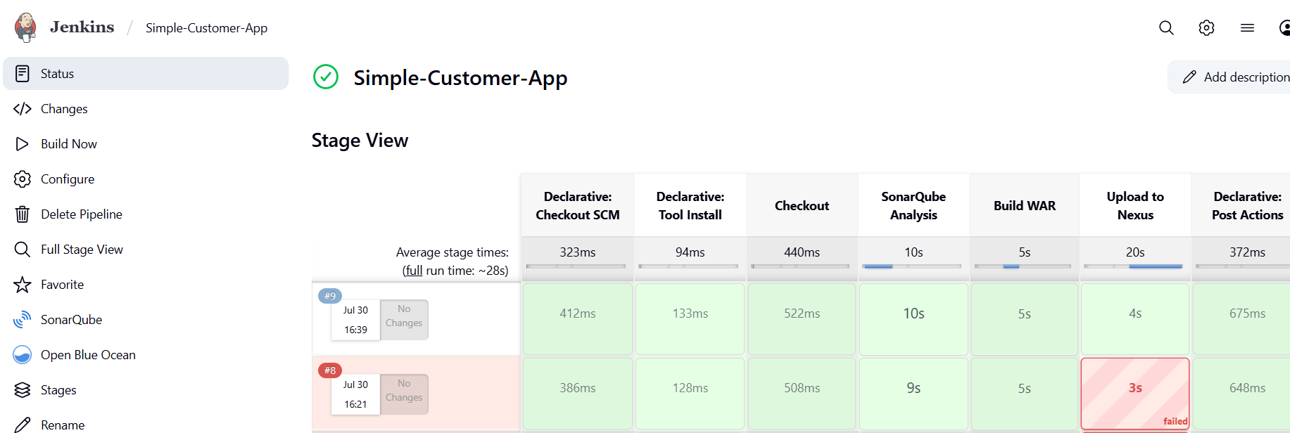

SonarQube output of Quality check.

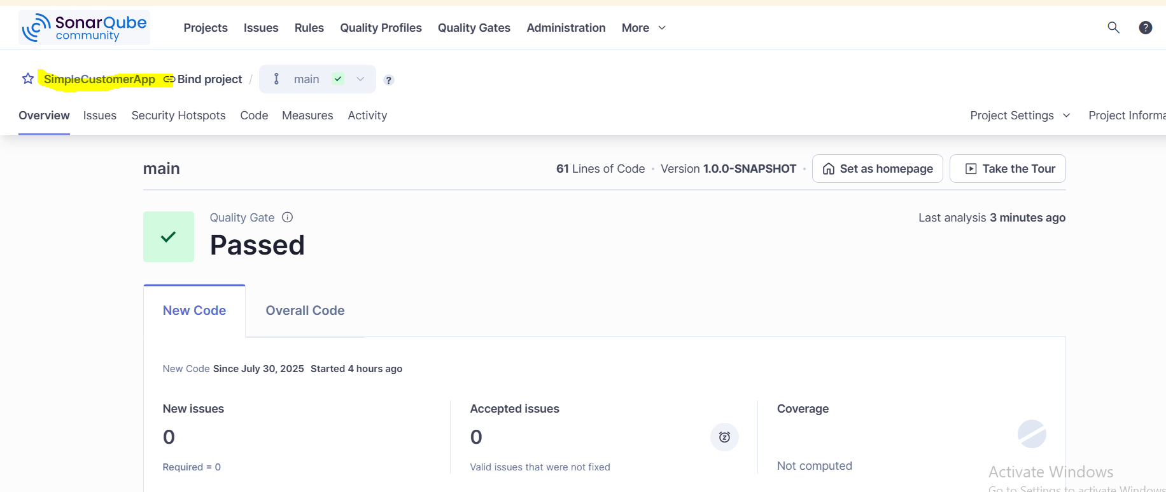

Artifact stored in nexus.

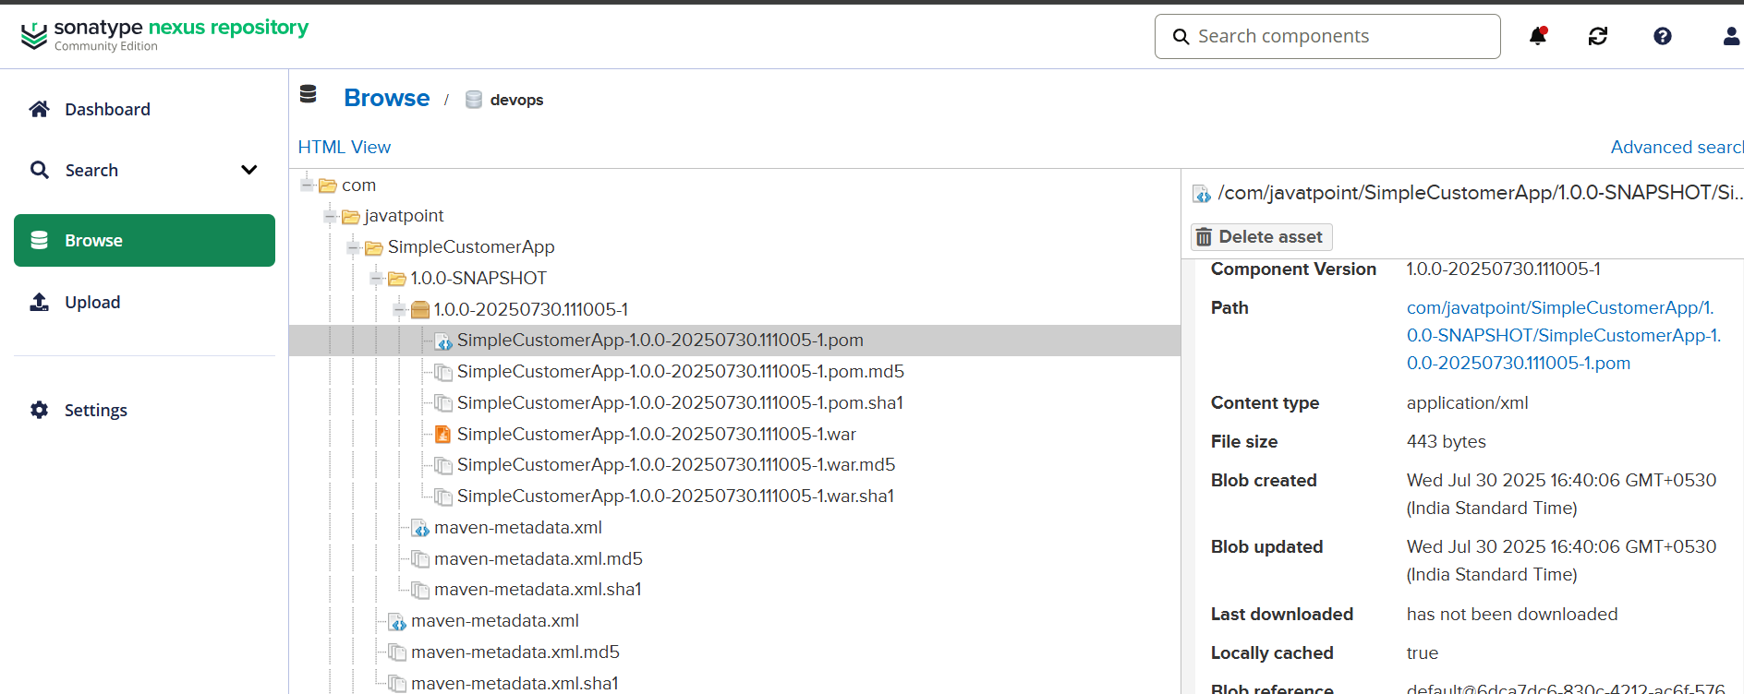
Post build action as Success.

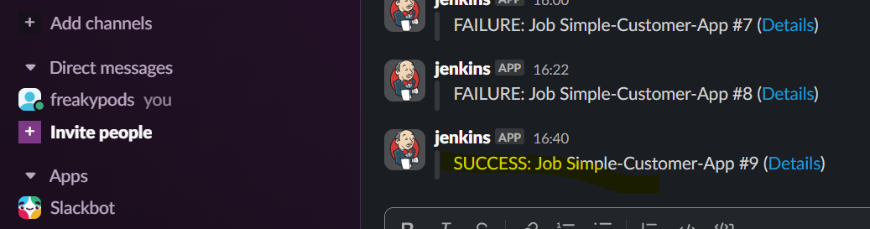

6)Create one declative job https://github.com/betawins/Trading-UI.git

pipeline {
agent any

stages {
stage('Checkout') {
steps {
checkout scm
}
}

stage('Install Dependencies') {
steps {
sh 'npm install'
}
}

stage('Build') {
steps {
// Disable CI mode to avoid ESLint errors failing the build
sh 'CI=false npm run build'
}
}

stage('Archive Build Artifacts') {
steps {
// Optional: archive the build folder
archiveArtifacts artifacts: 'build/**', fingerprint: true
}
}
}

post {
success {
echo 'Build succeeded!'
}
failure {
echo 'Build failed!'
}
}
}

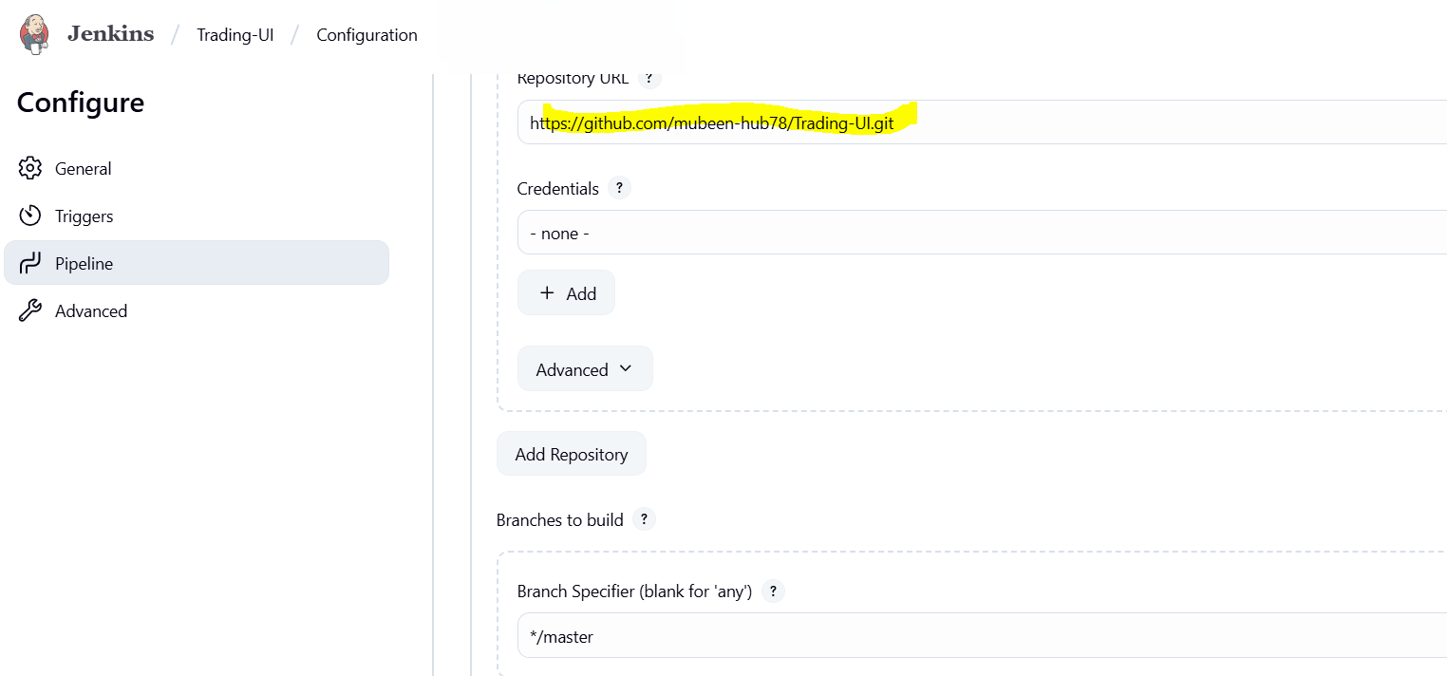

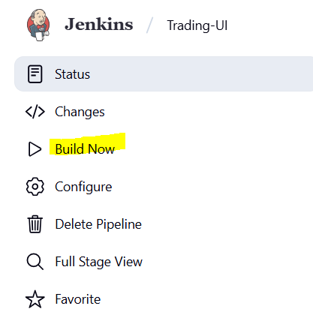
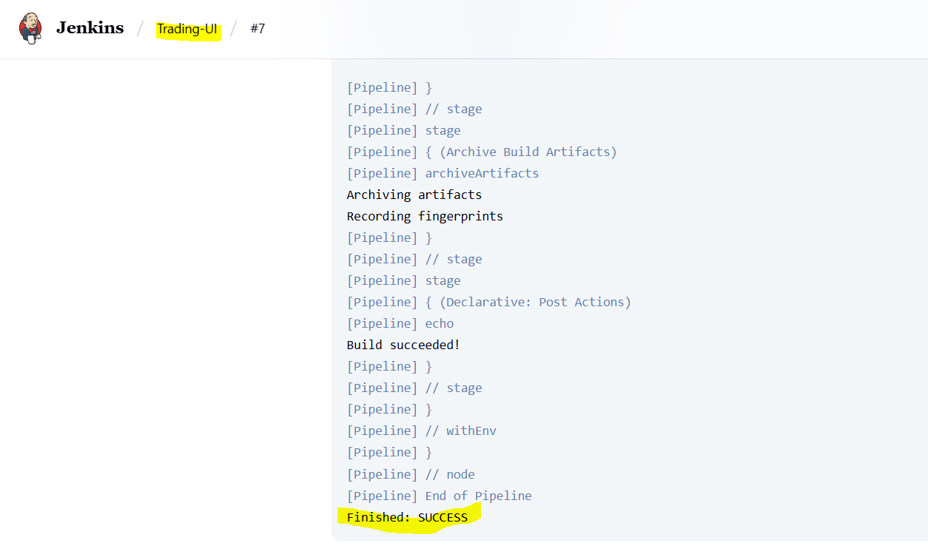
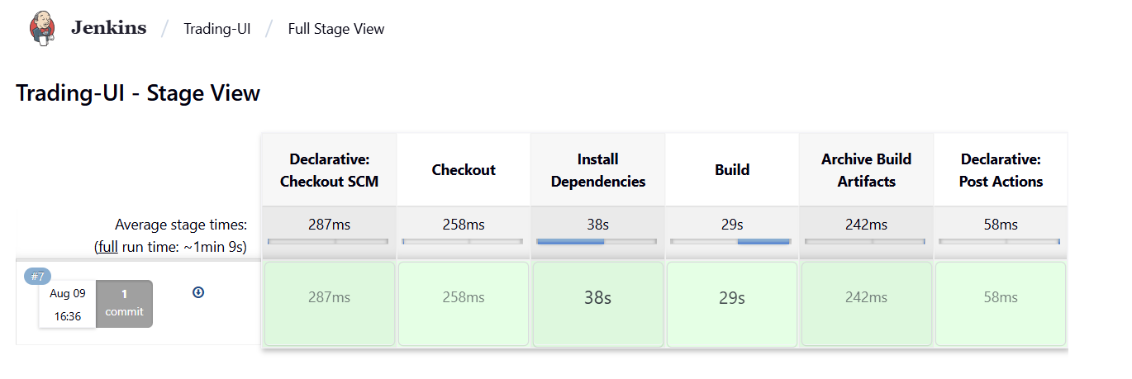
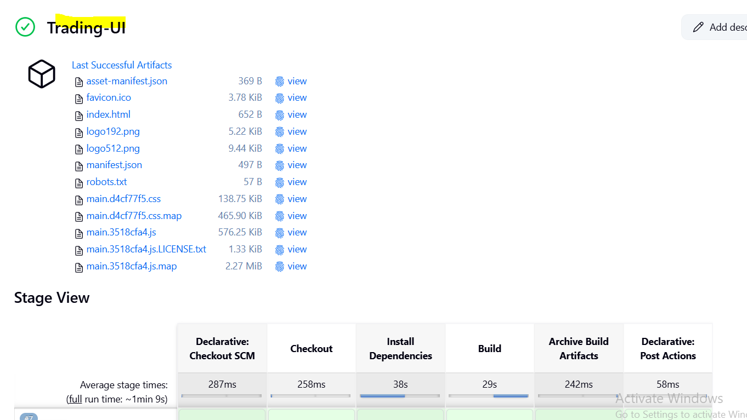

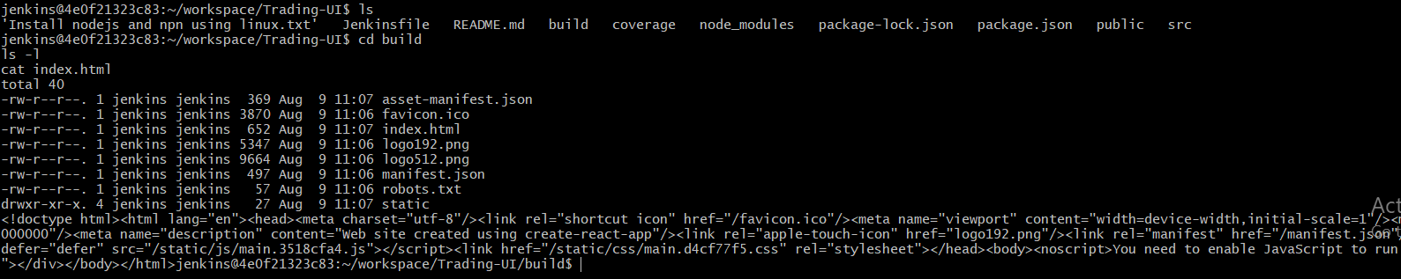

7) Execute parallel stages using jenkins pipeline for any sample job.

The parallel block allows defining multiple branches of execution within the same build stage that will run simultaneously, improving efficiency and making pipelines faster and more scalable. Use it when you have tasks that can safely run at the same time without depending on each other's results.

pipeline {
agent any

tools {
maven 'MAVEN_HOME'
}

environment {
NEXUS_VERSION = "${env.NEXUS_VERSION ?: 'nexus3'}"
NEXUS_PROTOCOL = "${env.NEXUS_PROTOCOL ?: 'http'}"
NEXUS_URL = "${env.NEXUS_URL ?: '107.23.211.86:8081'}"
NEXUS_REPOSITORY = "${env.NEXUS_REPOSITORY ?: 'devops'}"
NEXUS_CREDENTIAL_ID = "${env.NEXUS_CREDENTIAL_ID ?: 'Nexus_server'}"

SONARQUBE_SERVER = "${env.SONARQUBE_SERVER ?: 'MySonarQube'}"

SLACK_CHANNEL = "${env.SLACK_CHANNEL ?: '#new-channel'}"

REPO_URL = "https://github.com/mubeen-hub78/spring3-mvc-maven-xml-hello-world-1.git"
GIT_BRANCH = "master"
}

stages {
stage('Checkout') {
steps {
git branch: "${env.GIT_BRANCH}", url: "${env.REPO_URL}"
}
}

stage('Build & Analysis') {
parallel {
stage('Build') {
steps {
sh 'mvn -Dmaven.test.failure.ignore=true clean install'
}
}

stage('SonarQube Analysis') {
steps {
withSonarQubeEnv("${env.SONARQUBE_SERVER}") {
sh 'mvn sonar:sonar'
}
}
}
}
}

stage('Publish to Nexus') {
steps {
script {
def pom = readMavenPom file: 'pom.xml'
def artifacts = findFiles(glob: "target/*.${pom.packaging}")

if (artifacts.size() == 0) {
error "No artifact found for packaging type: ${pom.packaging}"
}

def artifactPath = artifacts[0].path

nexusArtifactUploader(
nexusVersion: "${env.NEXUS_VERSION}",
protocol: "${env.NEXUS_PROTOCOL}",
nexusUrl: "${env.NEXUS_URL}",
groupId: pom.groupId,
version: "${env.BUILD_NUMBER}-SNAPSHOT",
repository: "${env.NEXUS_REPOSITORY}",
credentialsId: "${env.NEXUS_CREDENTIAL_ID}",
artifacts: [
[artifactId: pom.artifactId, classifier: '', file: artifactPath, type: pom.packaging],
[artifactId: pom.artifactId, classifier: '', file: 'pom.xml', type: 'pom']
]
)
}
}
}
}

post {
success {
slackSend(channel: "${env.SLACK_CHANNEL}", color: 'good', message: "✅ SUCCESS: Job '${env.JOB_NAME} [${env.BUILD_NUMBER}]' (<${env.BUILD_URL}|Open>)")
}
failure {
slackSend(channel: "${env.SLACK_CHANNEL}", color: 'danger', message: "❌ FAILURE: Job '${env.JOB_NAME} [${env.BUILD_NUMBER}]' (<${env.BUILD_URL}|Open>)")
}
unstable {
slackSend(channel: "${env.SLACK_CHANNEL}", color: 'warning', message: "⚠️ UNSTABLE: Job '${env.JOB_NAME} [${env.BUILD_NUMBER}]'")
}
}
}

Explanation of Pipeline Blocks
- pipeline { ... }
Defines the entire Jenkins Declarative Pipeline, containing all stages, tools, environment variables, and post-build actions.
- agent any
Instructs Jenkins to execute the pipeline on any available agent (node).
- tools { maven 'MAVEN_HOME' }
Declares that Maven (configured in Jenkins as MAVEN_HOME) will be used for building the project.
- environment { ... }
Sets global environment variables for the pipeline, including:
  - Nexus repository details: version, protocol, URL, repository name, and credentials.
  - SonarQube server name configured in Jenkins.
  - Slack channel to send build notifications.
  - Git repository URL and branch to checkout the code.
- stages { ... }
Contains all pipeline stages like checkout, build, code analysis, and artifact publishing.

Stage Explanations
- stage('Checkout')
Clones the source code from the specified Git repository (REPO_URL) and branch (GIT_BRANCH) using the git step.
- stage('Build')
Runs the Maven command mvn clean install to:
  - Compile the Java source code.
  - Run tests (if any) — test failures are ignored due to -Dmaven.test.failure.ignore=true.
  - Package the output artifact (WAR/JAR file).
- stage('SonarQube Analysis')
Runs static code analysis with SonarQube to check for code quality issues:
  - Uses the Jenkins-configured SonarQube server (MySonarQube).
  - Sends metrics like bugs, vulnerabilities, and code coverage to the SonarQube dashboard.
- stage('Publish to Nexus')
Uploads the generated Maven artifact (e.g., WAR/JAR) to the Nexus repository:
  - Reads project metadata (groupId, artifactId, version) from pom.xml.
  - Finds the generated artifact in the target directory.
  - Authenticates to Nexus using Nexus_server credentials stored in Jenkins.
  - Uploads both the artifact and its POM file to Nexus.

post { ... }
Defines actions that are executed after all stages finish, based on build status:
- success
Sends a green Slack notification indicating the build succeeded.
- failure
Sends a red Slack notification when any stage fails.
- unstable
Sends a yellow Slack notification if the build is marked as unstable (e.g., test failures or quality gate failure).

Configure the job.
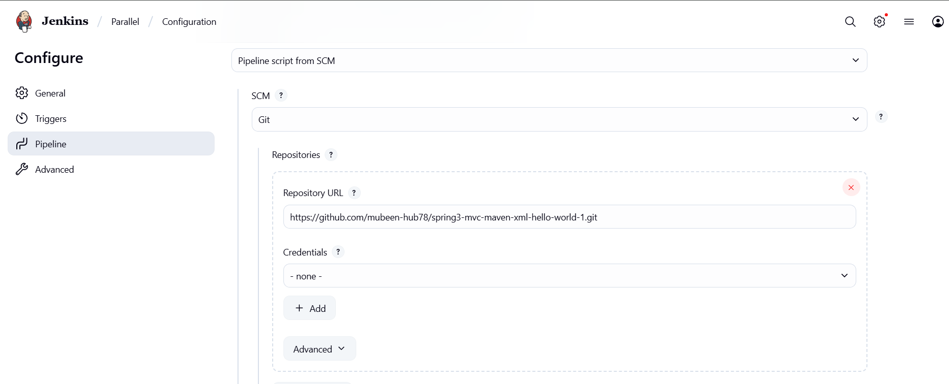

Click on Build.
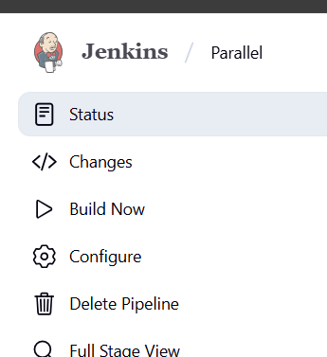

Console output and stage view.
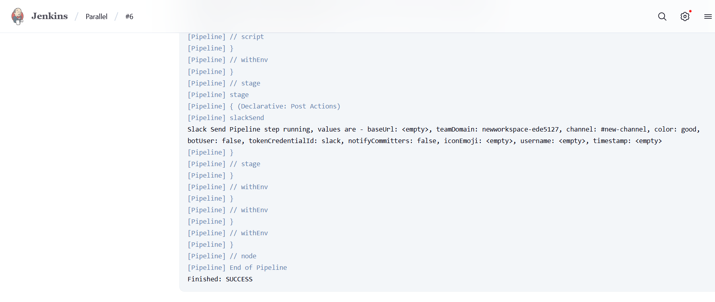
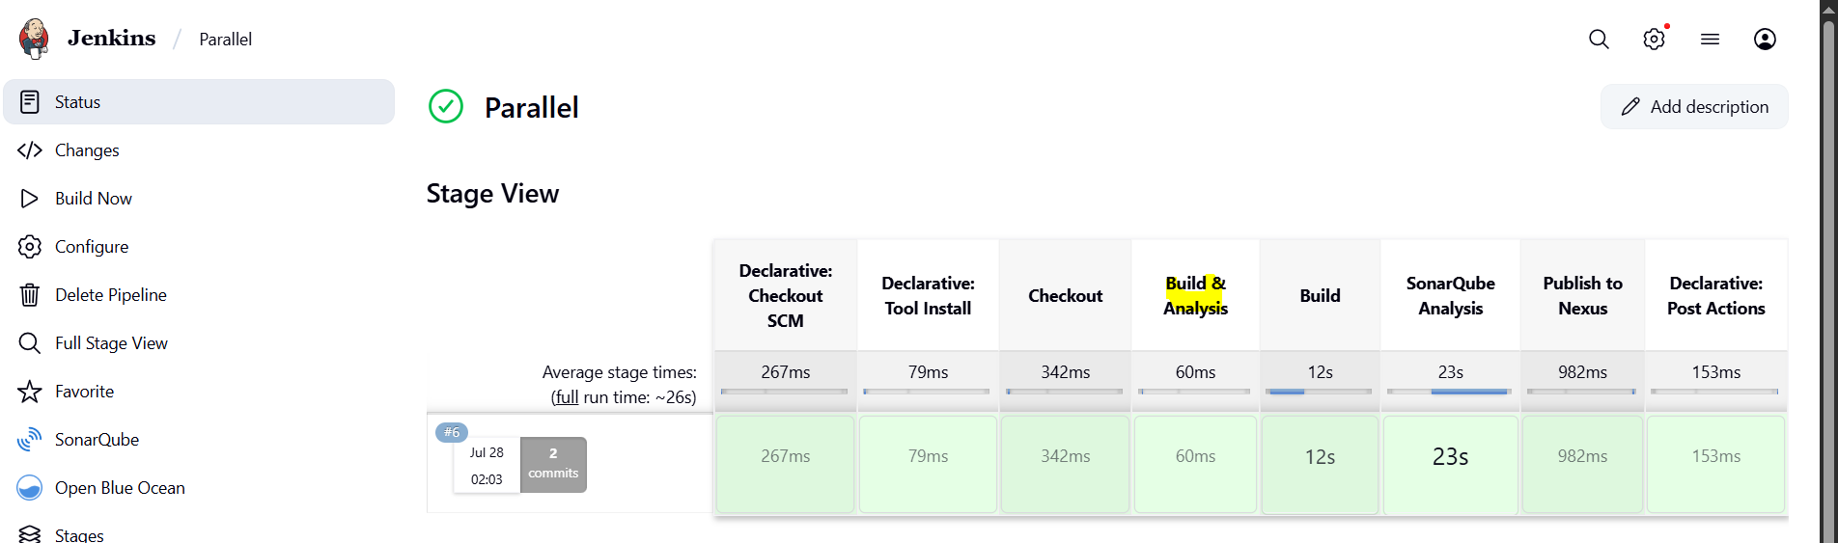

SonarQube code Quality check.
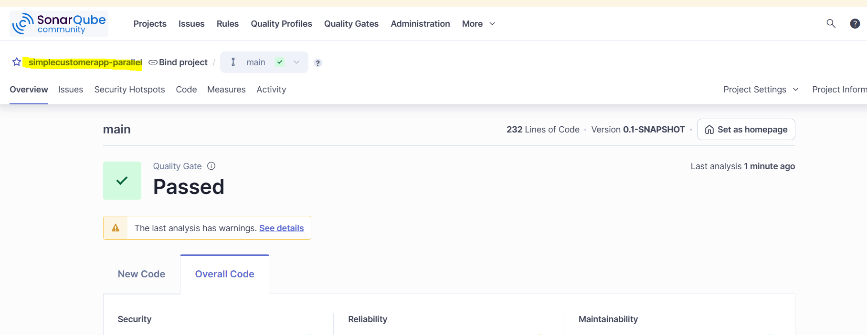

Artifact stored in nexus.

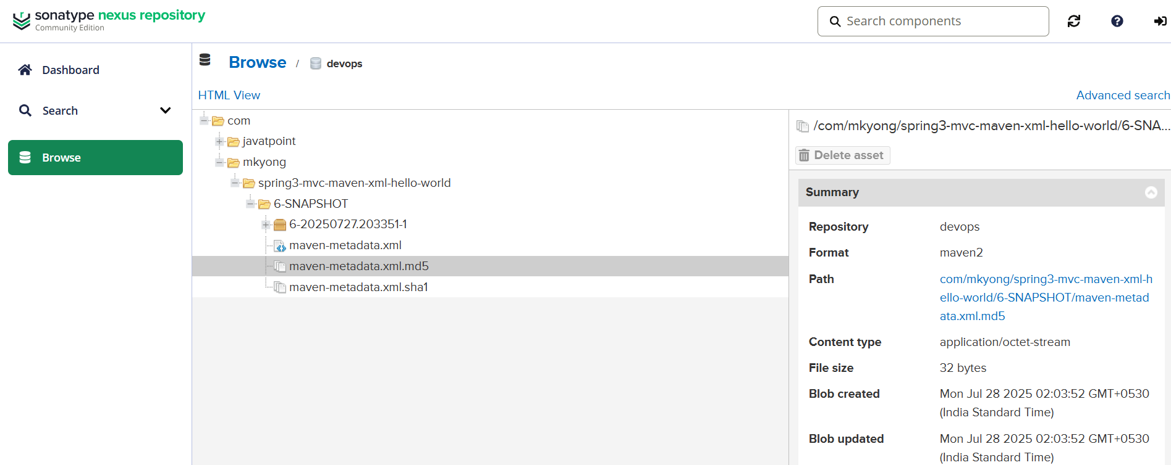

Post buld action as Success.

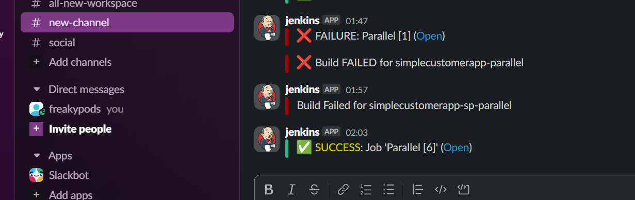

8) Execute jenkins pipeline stages using shared libraries. Ref: https://phoenixnap.com/kb/jenkins-shared-library

Step 1: Prepare Your Shared Library Repository
Create a Git repository with this folder structure:

vars/
exampleStep.groovy
src/
resources/
README.md
Example content for vars/exampleStep.groovy:

def call(String name = 'World') {
echo "Hello, ${name}!"
}
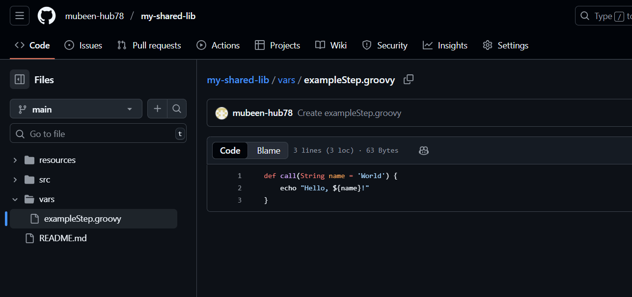

Step 2: Configure Jenkins to Use the Shared Library
Log in to Jenkins.
Navigate to Manage Jenkins → Configure System → Global Pipeline Libraries.
Click Add and enter the library details:
Name: my-shared-lib
Default version: branch name, e.g., main
Retrieval method: Modern SCM (Git URL of your shared library repo).
Leave "Load implicitly" unchecked.
Click Save.
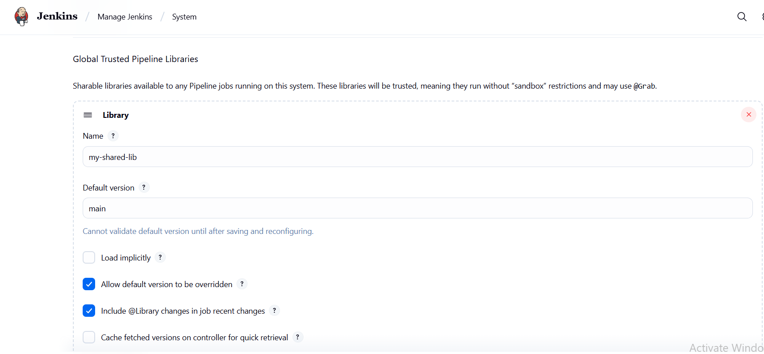

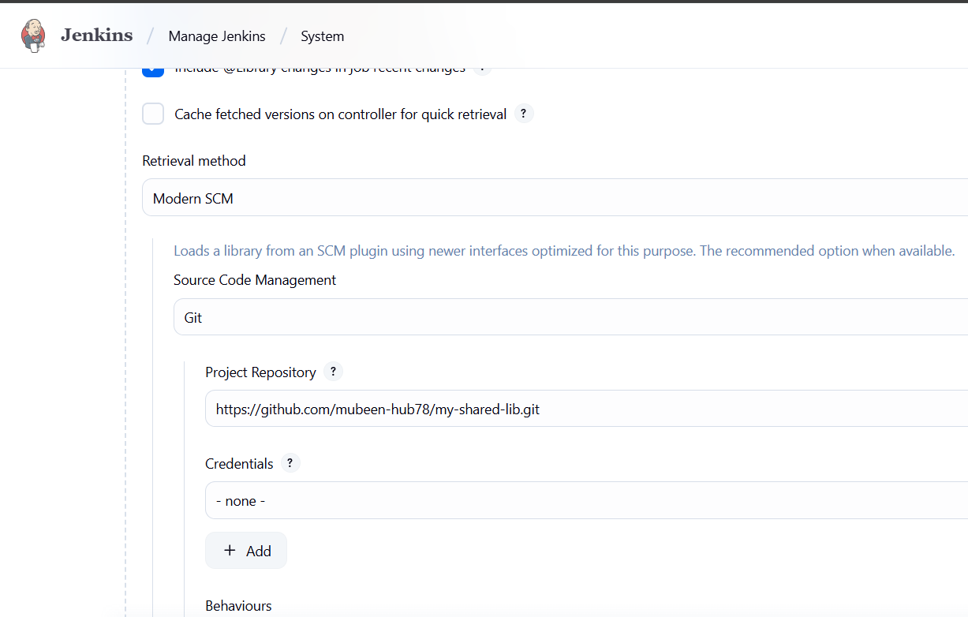

Step 3: Create a Jenkins Pipeline Job Using the Shared Library
In Jenkins, click New Item, enter a pipeline name, and select Pipeline.
In the pipeline script section, add this Jenkinsfile code:

@Library('my-shared-lib') _
pipeline {
agent any
stages {
stage('Example') {
steps {
exampleStep('DevOps Engineer')
}
}
}
}
Click Save.
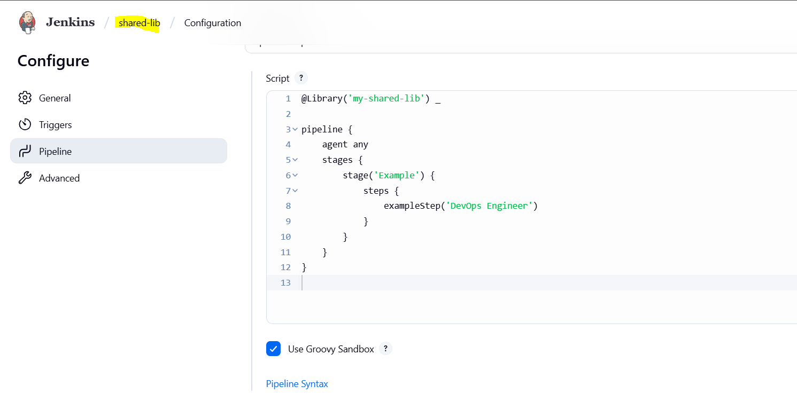

Step 4: Run the Pipeline Job
Click Build Now to trigger the job.
Open the Console Output of the build.
You should see the output: Hello, DevOps Engineer!

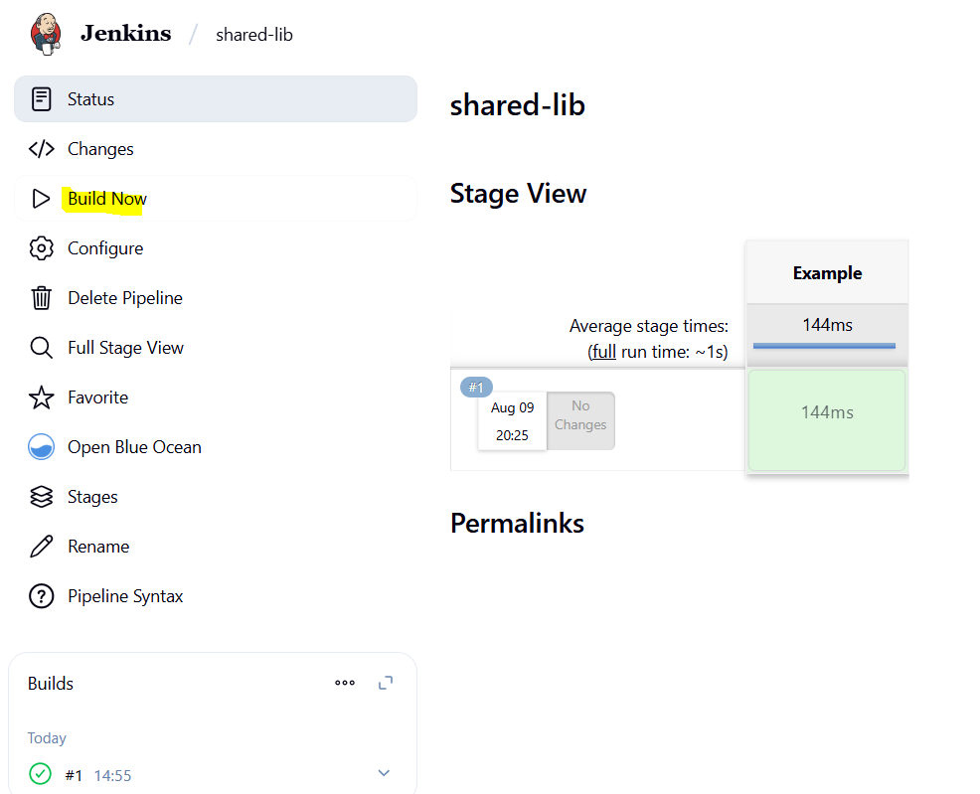
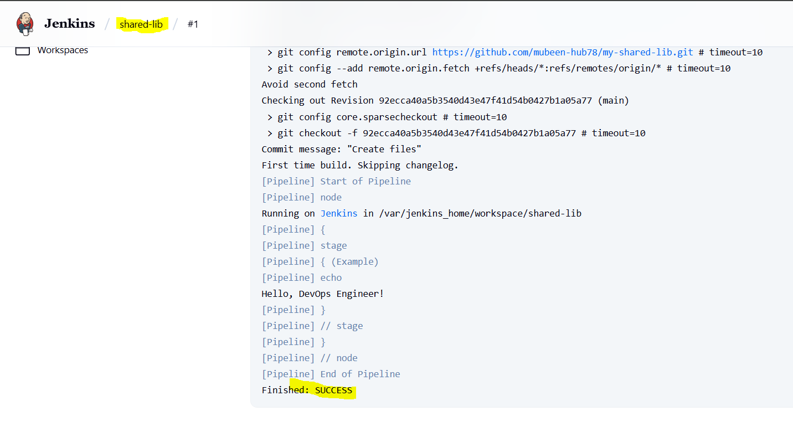

THE-END

